**TUGAS PERTEMUAN 4**

Nama : Martin Caesar Partogi

NPM : 242310034

Kelas : TI-24-PA2

**Screenshoot OUTPUT If Else**

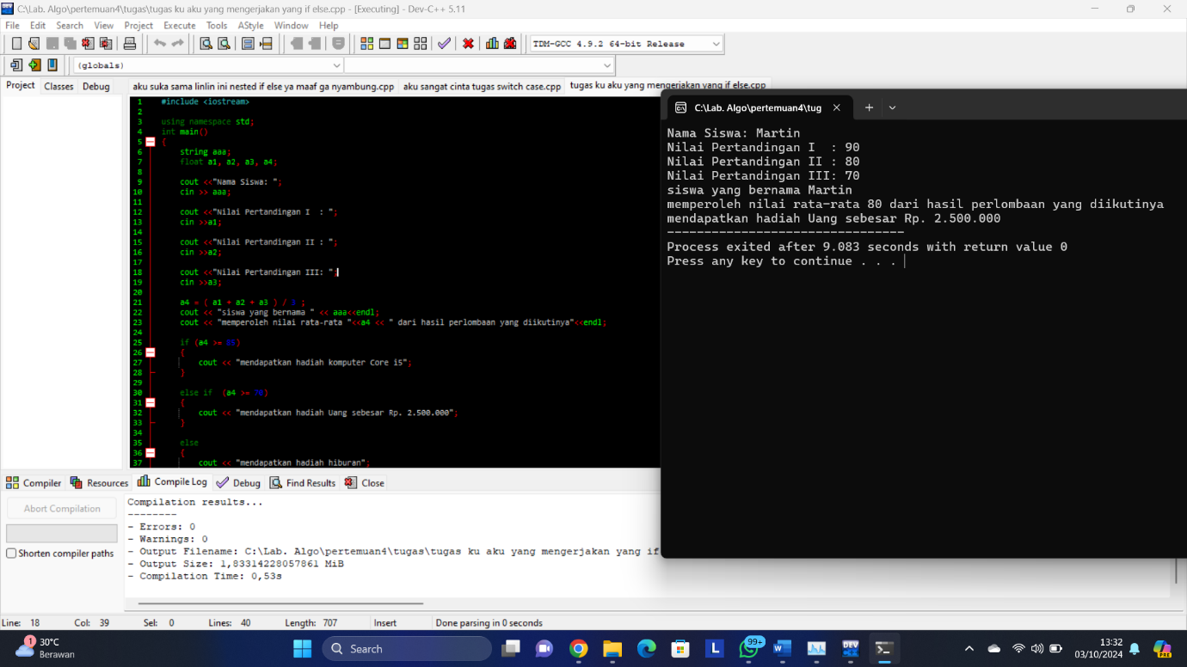

**Screenshoot CODING If Else**

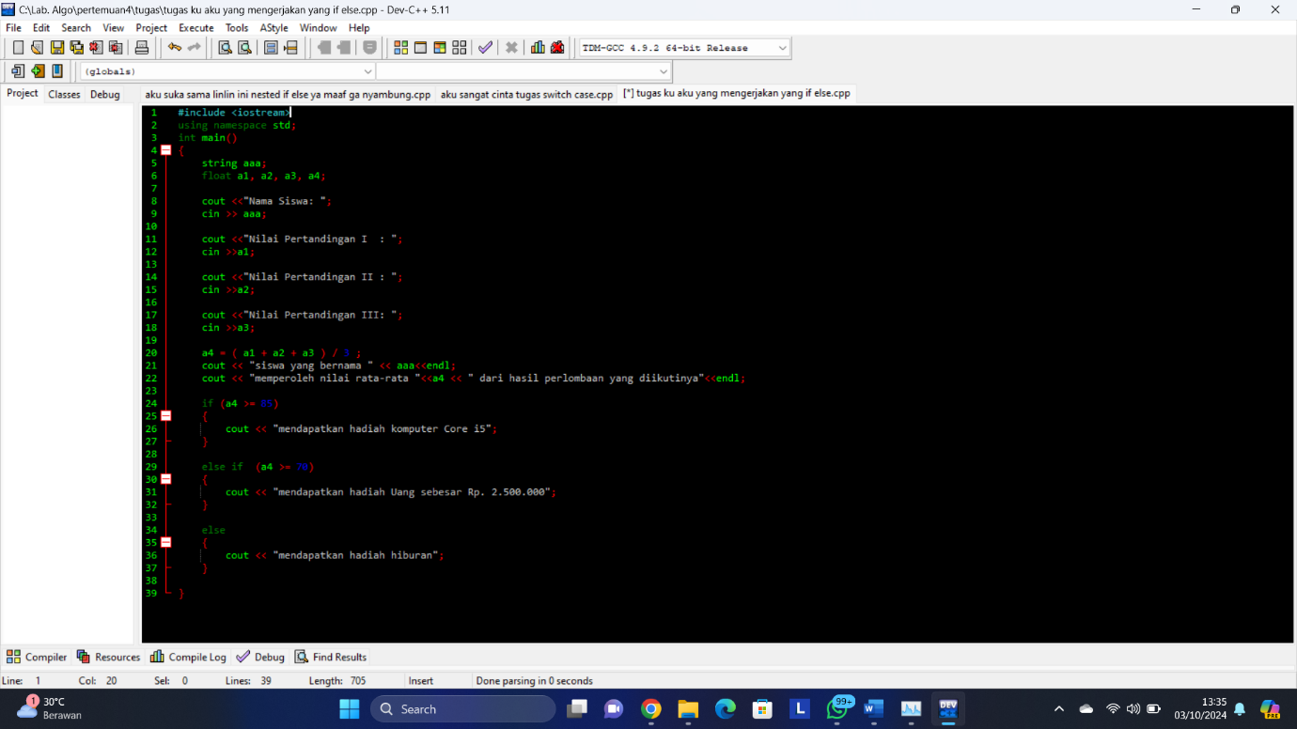

**Screenshoot OUTPUT Nested If Else**

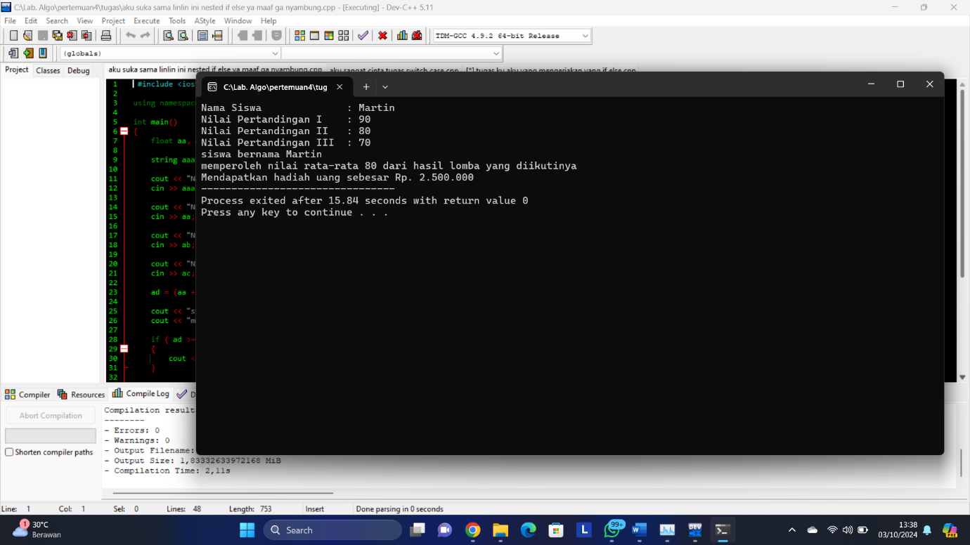

**Screenshoot CODING Nested If Else**

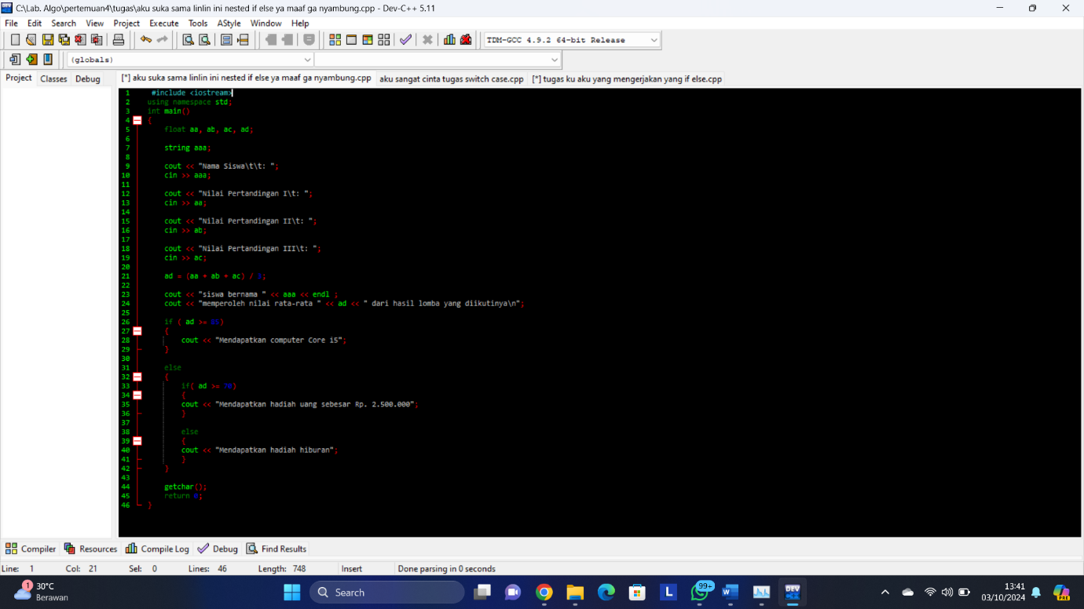

**Screenshoot OUTPUT Swicth Case**

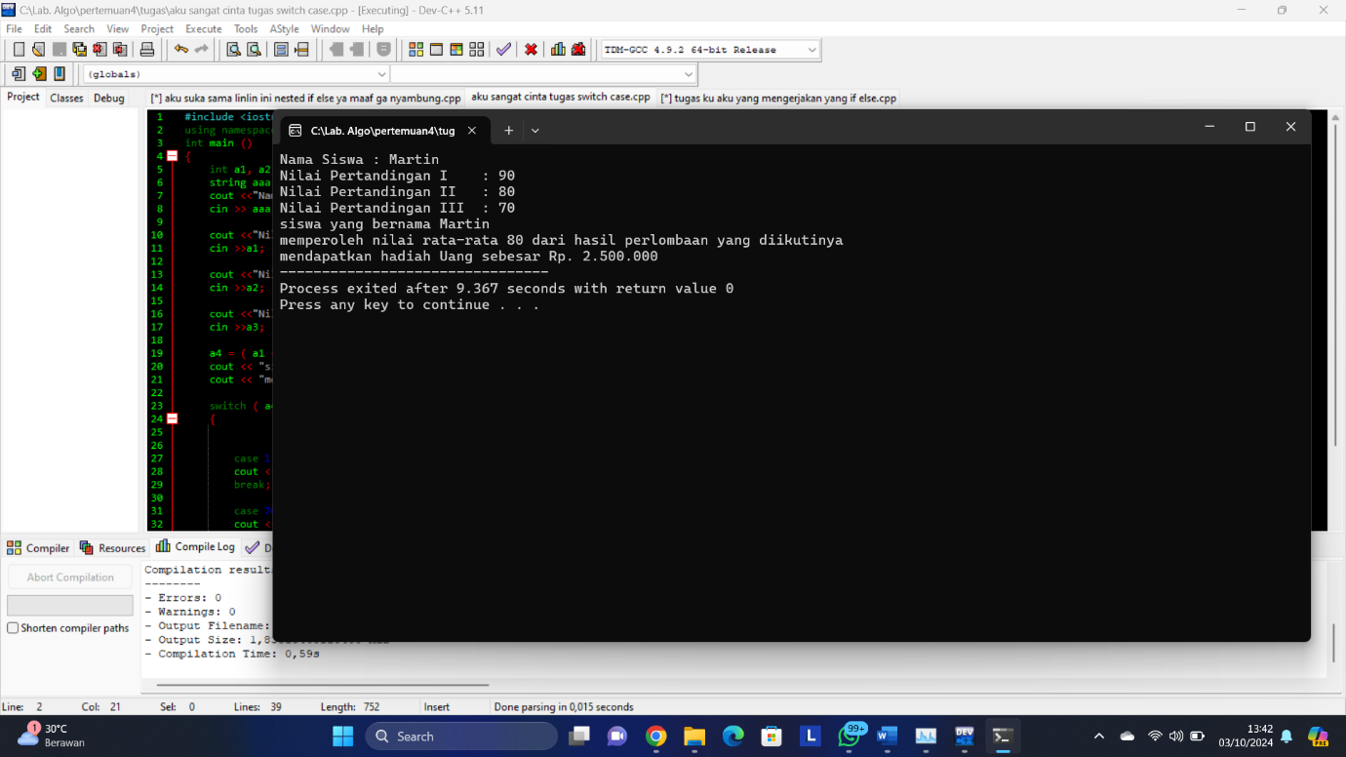

**Screenshoot CODING Swicth Case**

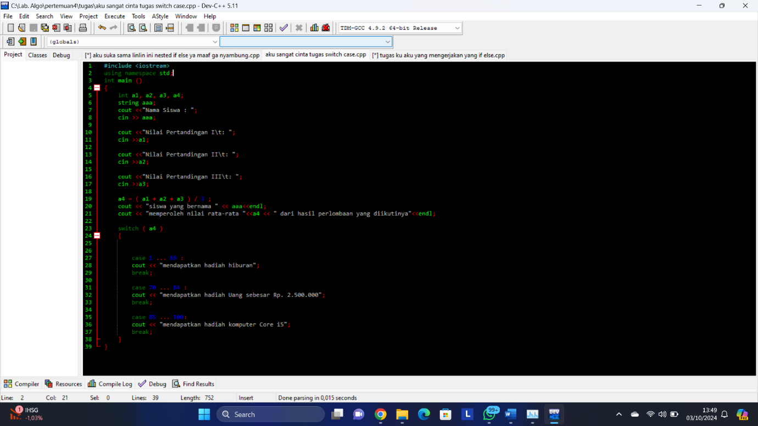

**Screenshoot WAKTU**

